Password Protecting Word Documents:

- With your document open, select “Tools” from the toolbar
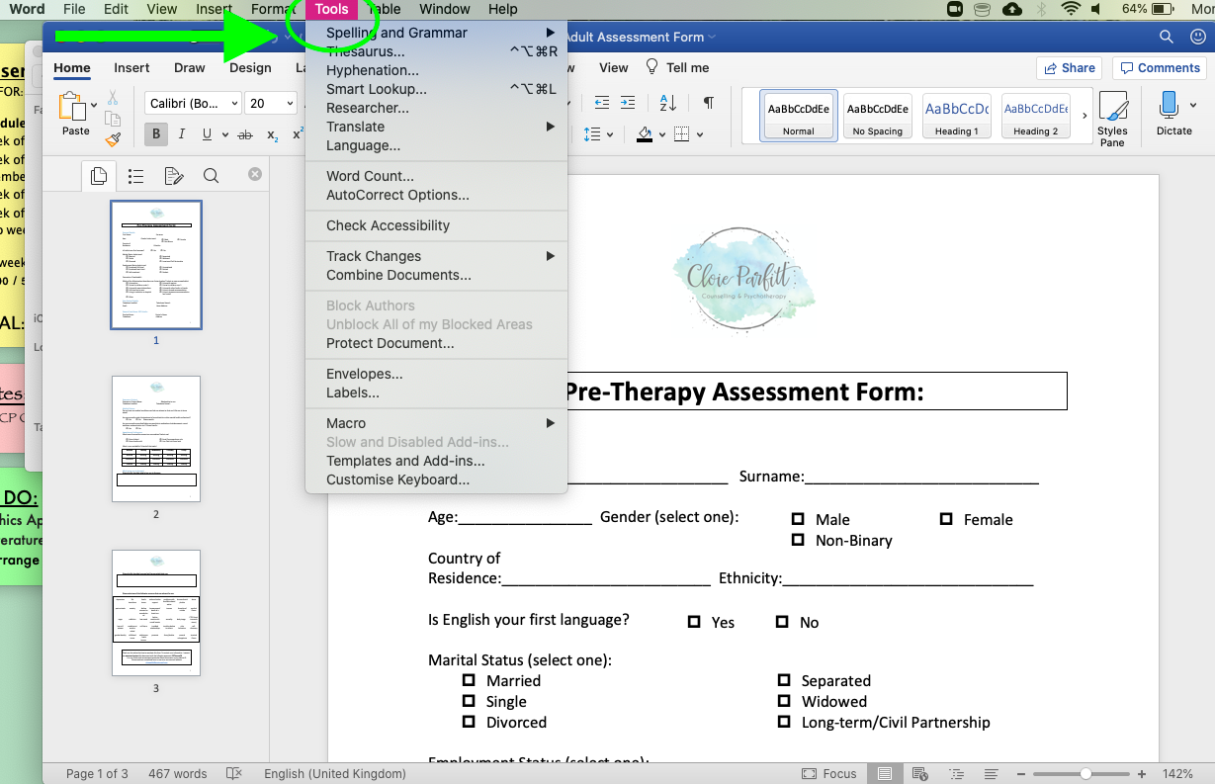

- Then select “Protect Document” from the dropdown menu.
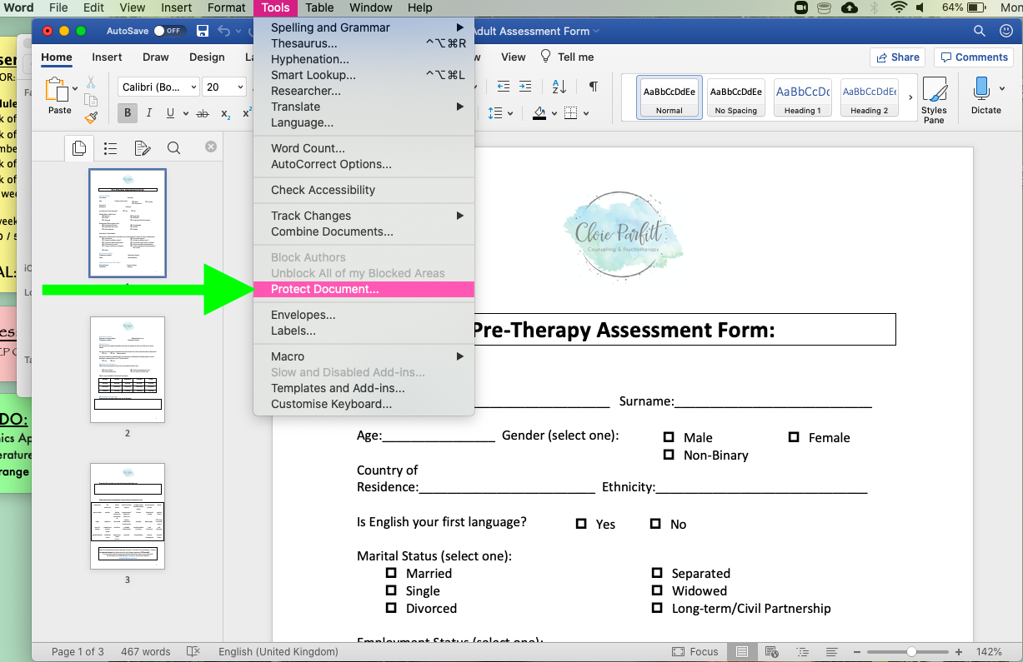

- You will then be prompted to enter a password for the document. For completed assessment forms, please set the password to CPTherapy20
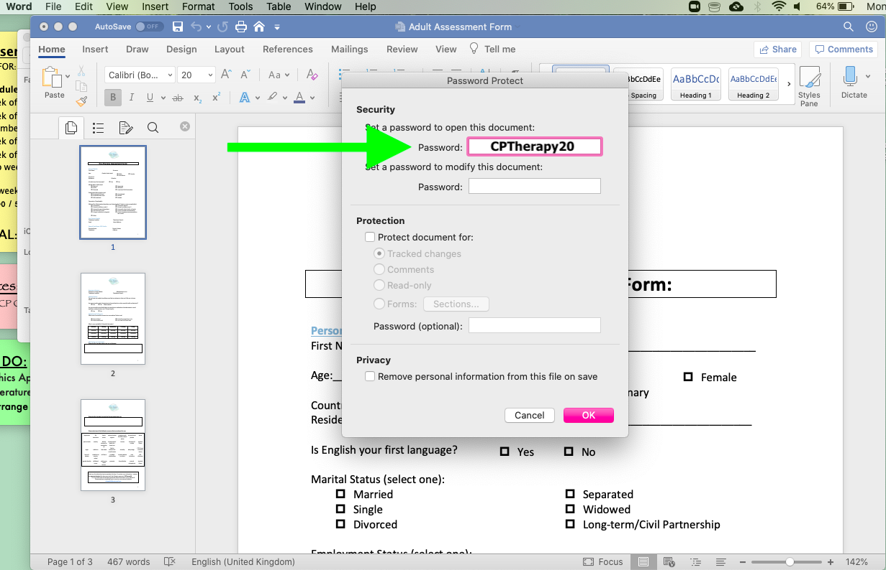

- Once you’ve entered your password twice, you can then click “OK” and your password will be saved.
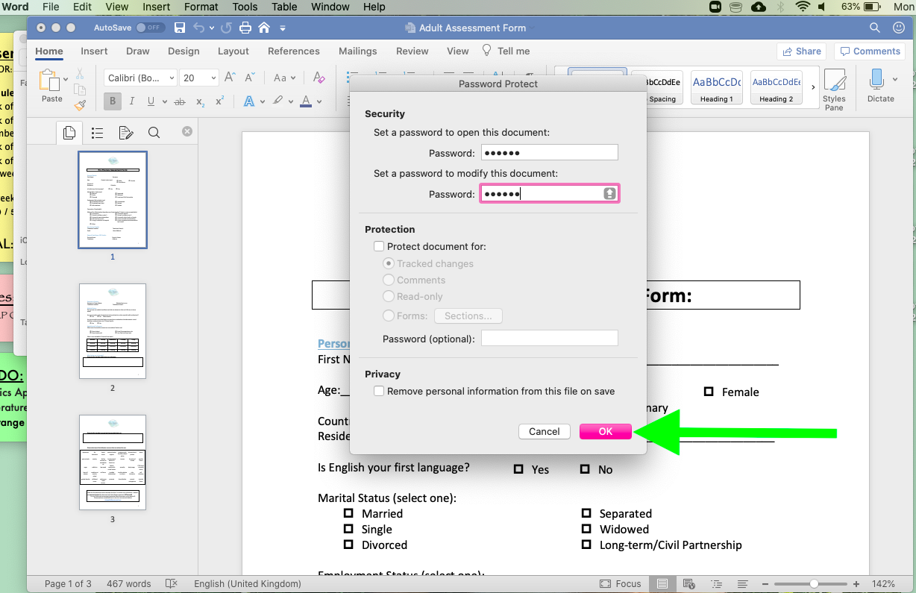

- You will now need to enter this password whenever you wish to open the document, so make a note of this password for your reference.

